Name: Linn Brown

- Identify all entities
The entities are:
- CUSTOMER- who is a registered shopper
- ADDRESS- the delivery address belonging to the customer
- ORDER- purchase made by the customer
- PRODUCT- item for sale
- CATEGORY- product category or classification
- SUPPLIERS- the company that supplies the product
- DELIVERY- the delivery record for the order
- PAYMENT- the payment record for the order

- Identify primary keys
ENTITY | PRIMARY ID
CUSTOMER | CUSTOMER ID
ADDRESS | ADDRESS ID
ORDER | ORDER ID
PRODUCT | PRODUCT ID
CATEGORY | CATEGORY ID
SUPPLIER | SUPPLIER ID
DELIVERY | DELIVERY ID
PAYMENT | PAYMENT ID

- Identify foreign keys
ENTITY | FOREIGN ID
ADDRESS | CUSTOMER ID
ORDER | CUSTOMER ID  PRODUCT ID
PRODUCT | SUPPLIER ID  CATEGORY ID
CATEGORY | PRODUCT ID
DELIVERY | ORDER ID  ADDRESS ID
PAYMENT | ORDER ID

- Identify relationships
Customer ADDRESS
Customer ORDERS
Product ORDERS
Order PRODUCT
Supplier PRODUCT
Category PRODUCT
Order DELIVERY
Address DELIVERY
Order PAYMENT

- Show cardinality:
  - One-to-one (1:1)
  - One-to-many (1:M)
  - Many-to-many (M:N)
Customer ADDRESS (ONE TO MANY)
Customer ORDERS (ONE TO MANY)
Product ORDERS (ONE TO MANY)
Order PRODUCT (ONE TO MANY)
Supplier PRODUCT (ONE TO MANY)
Category PRODUCT (ONE TO MANY)
Order DELIVERY (ONE TO ONE)
Address DELIVERY (ONE TO MANY)
Order PAYMENT (ONE TO ONE)

- Draw a complete ERD including:
  - Entities
  - Attributes
  - Relationships
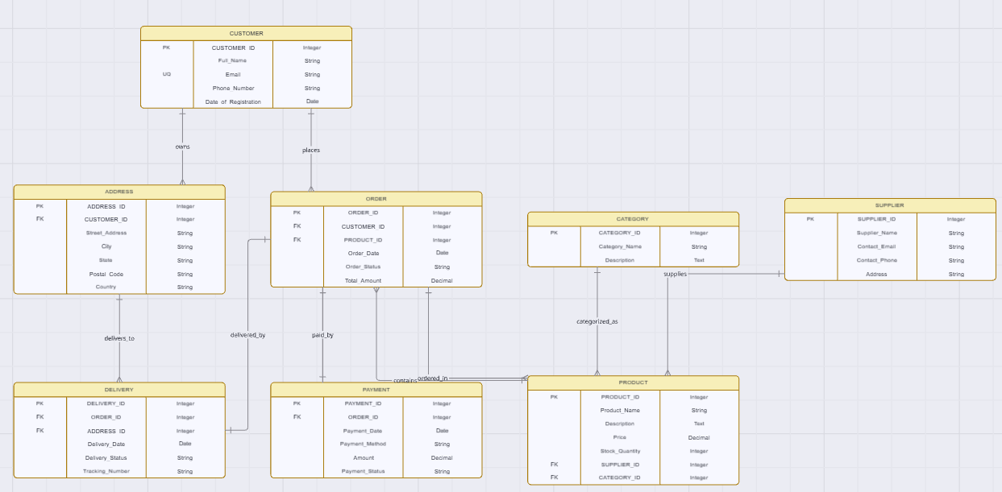

I used miro to generate this but all attemps made to develop own my own is there another site I could use?

